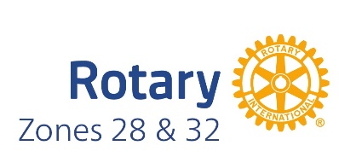
Public Image CHECKLIST
Do
Review the materials on Brand Center (brandcenter.rotary.com)
Create your own club logo from Brand Center (template on Brand Center)
Create a club brochure if you don’t have one (template on Brand Center)
Create a club presentation if you don’t have one (template on Brand Center)
Include the Rotary logo (Rotary + wheel) with your club or district name on your materials
Use Arial or Arial Narrow (all upper case) for headlines, Georgia for text for free fonts
Use Rotary colors: Azure, Royal Blue, Gold, Sky Blue as primary colors: See Brand Center for the color values
Use photographs that reflect Rotarians in action: high resolution, diverse people
If not using photographs, use graphics that reflect the iconography style:
simple, modern, informative
Ensure your promotion materials reflect the Rotary operating principles:
Join Leaders, Exchange Ideas, Take Action
Make sure your “voice” is smart, compassionate, persevering, inspiring—reflect that in how you speak, write, and design
Include a call to action on every communications deliverable (email, website, Facebook, phone number)—tell readers what they should do
Be inspirational and human in all of your communications!

Don’t
Use the old Rotary logo
Change the new Rotary logo (color, reformatted, cropped, additional imagery)
Use the wheel by itself
Make the logo and mark the same size: The wheel should be 4x the height of the logo if you use both
Use upper and lower case in headlines
Use clip art imagery that is cartoonish—it should reflect the Rotary operating principles, voice, and iconographic style

